ANSABLE -01
- Watch ansible-01 video and write down notes.
Ansible is an open-source configuration management and automation tool.
It is used to automate IT tasks such as software installation, system configuration, application deployment, and server management.
Ansible allows administrators to manage multiple servers from a single control machine using SSH, without installing any agent on the target systems.
- Key Features of Ansible
- Agentless: No software needs to be installed on managed nodes
- Automation tool: Reduces manual work
- Uses YAML: Easy to read and write
- Idempotent: Running the same task multiple times gives the same result
- Scalable: Can manage one server or thousands
- How Ansible Works
- A Control Node runs Ansible
- Managed Nodes are the target servers
- Instructions are written in Playbooks
- Playbooks contain tasks that describe the desired state of systems
- Uses of Ansible
- Installing and configuring software
- Managing server configurations
- Deploying applications
- Automating repetitive administrative tasks
- Managing cloud and on-premise infrastructure
- Conclusion
Ansible simplifies infrastructure management by automating repetitive tasks, ensuring consistency across servers, and reducing human error.
- Setup one master and two worker nodes in ansible.
Launch 3 instances 1 is master
2 workers
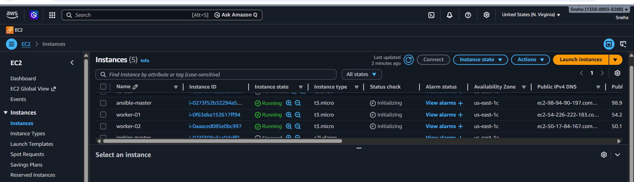
- Go to the root user
- Check the version of python
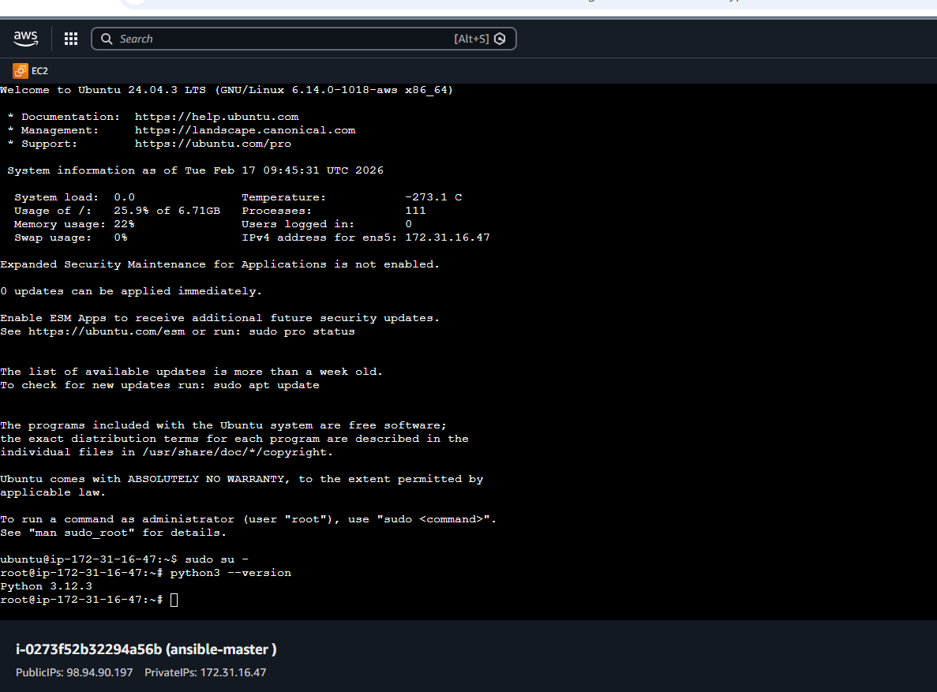
- Install ansible
- apt update
- apt install ansible -y
- ansible –version
- Check the version of the ansible
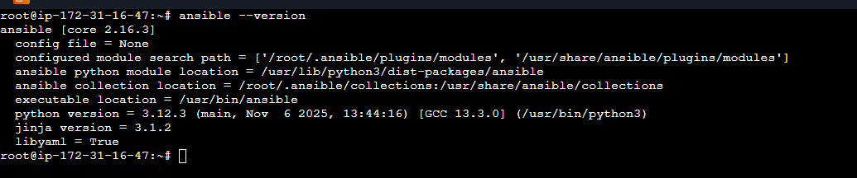
- Create a directory
- mkdir -p /etc/ansible
- directory has been created
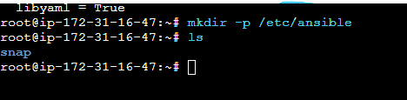

- Create a file
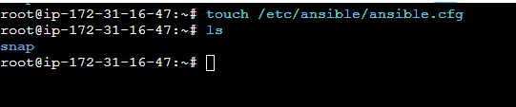
- Configuration path
- vi /etc/ansible/ansible.cfg
- Add the configuration

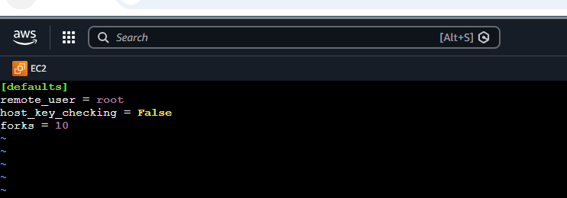
- Create Inventory File (hosts)
- cd /etc/ansible
- vi hosts

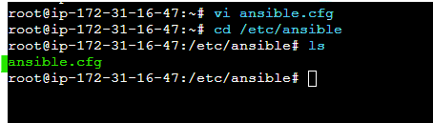

- Insert the private key
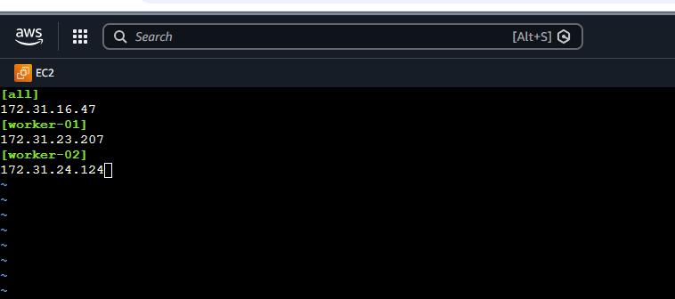
- sh-keygen
- Created key pair:
- cat /root/.ssh/id_ed25519.pub
- Copied public key
- This key will be pasted on worker nodes
- Purpose: Passwordless SSH from controller to workers
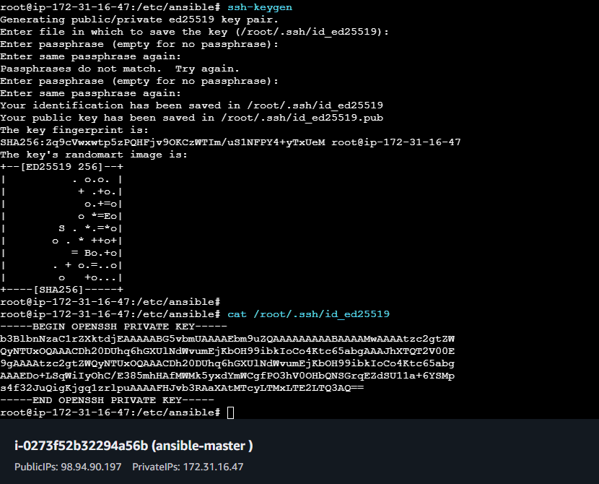
- Check for authorize keys
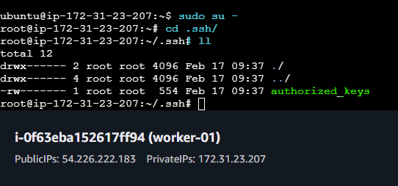

- Paste hear ssh-keygen from controller to worker -01
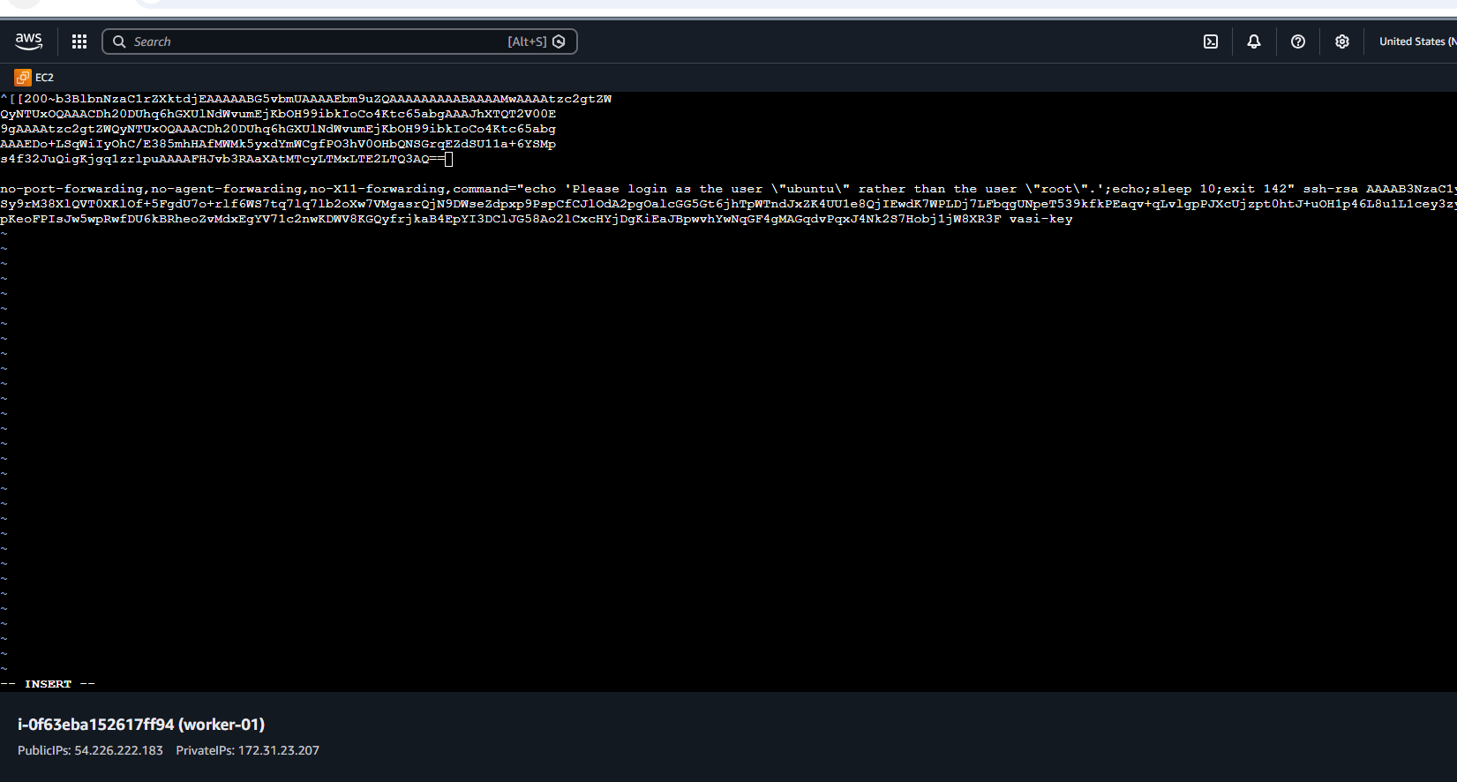
- Check the authorized_keys
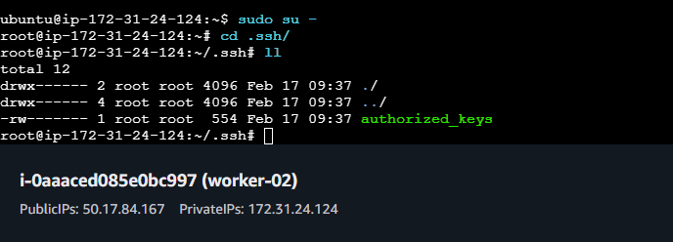
- Pster the pub key in worker one
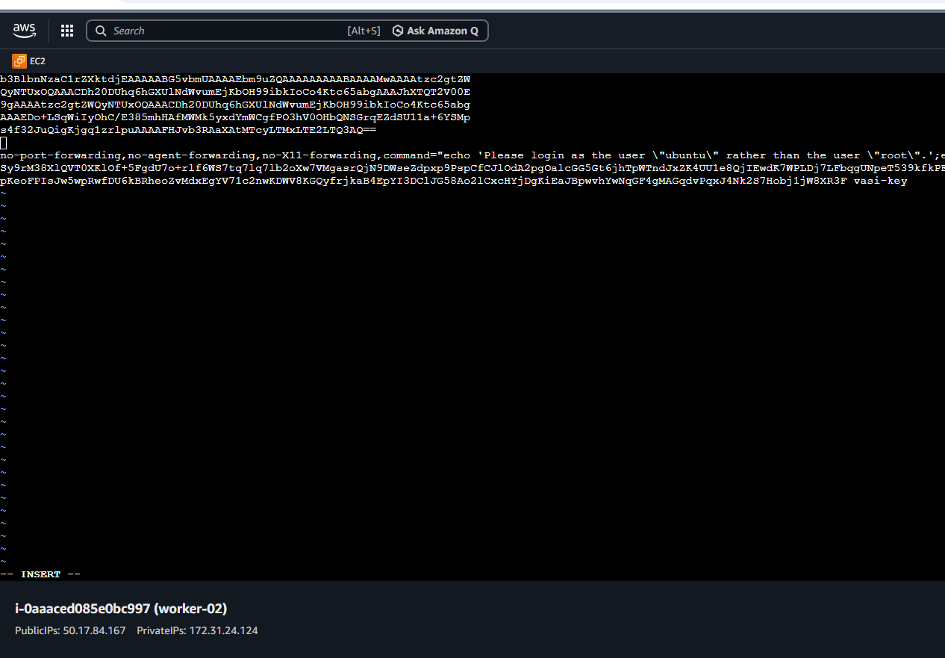
- Go to the ansible master and
- Ping the worker one
- Successfully ping
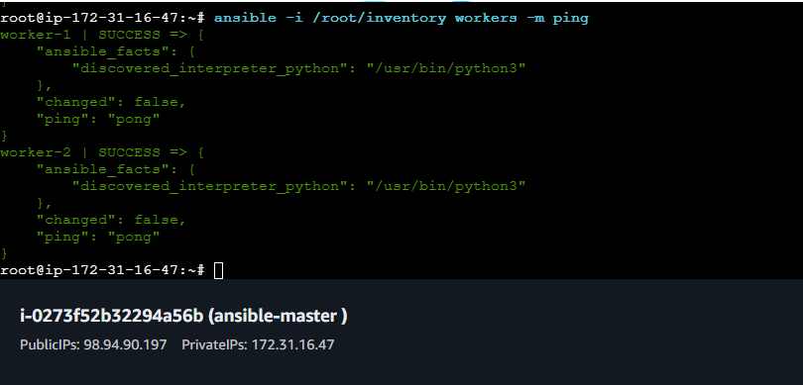

3.Execute the adhoc command shared in #dvps-cloud-documents-12 Channel.
Ansible --version
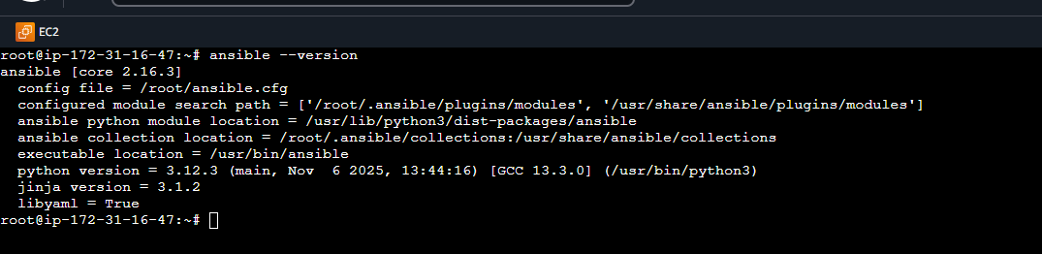
- Ansible –list
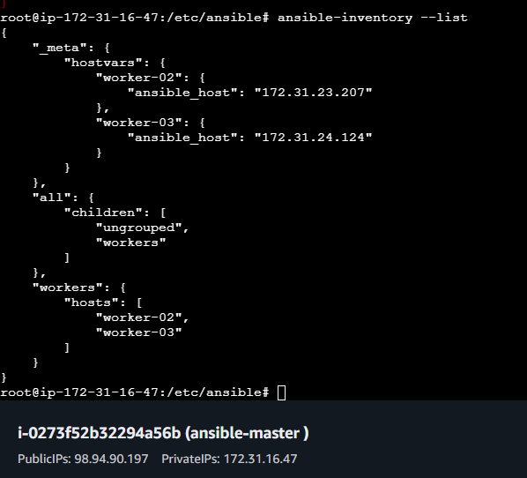
- Ansible all -a “uptime”
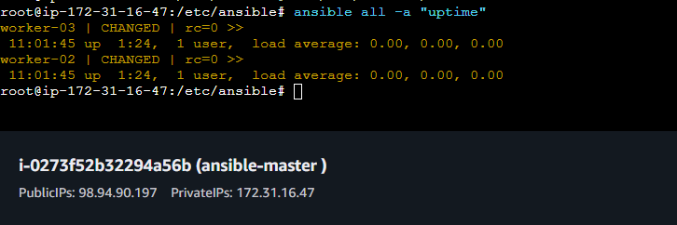
ansible workers -b -m apt -a "name=nginx state=present update_cache=yes"
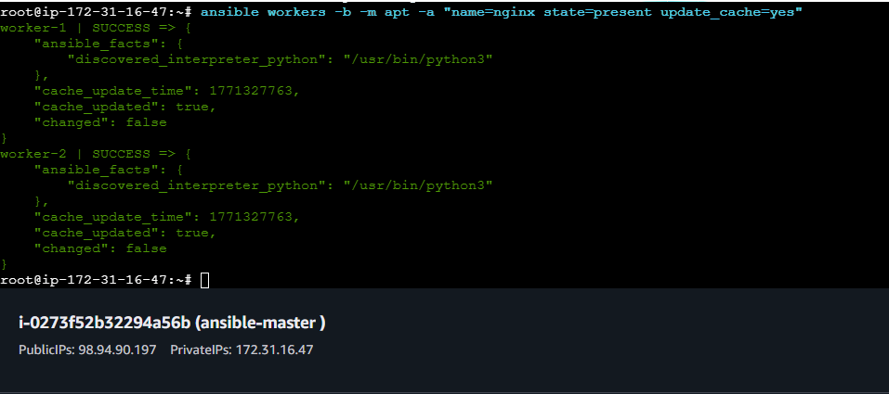
ansible workers -b -m service -a "name=nginx state=started"
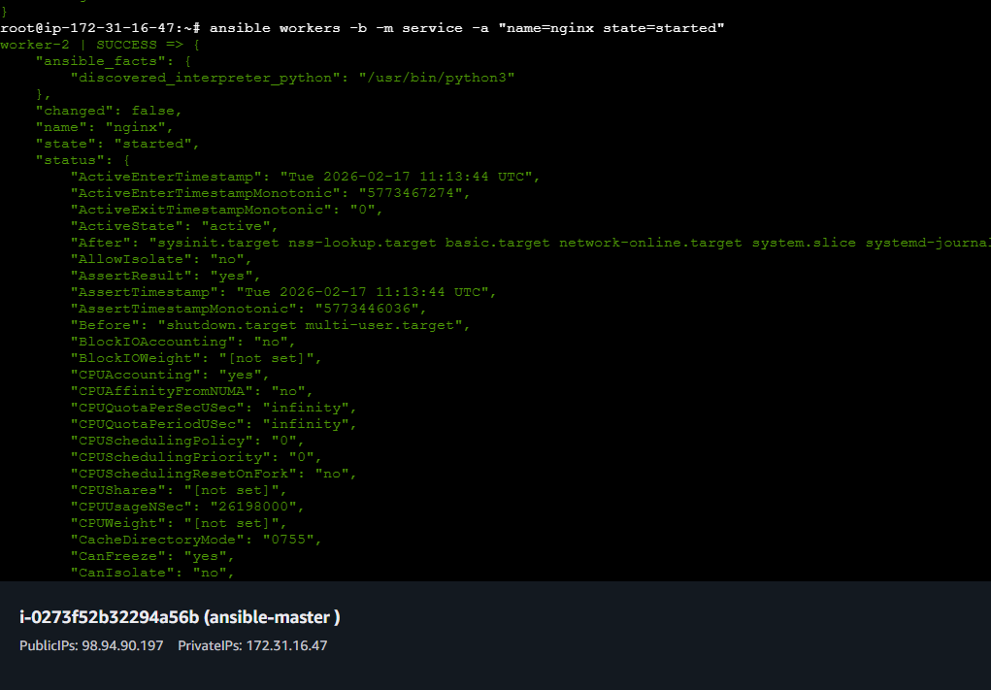

ansible workers -m copy -a "src=test.txt dest=/tmp/test.txt"
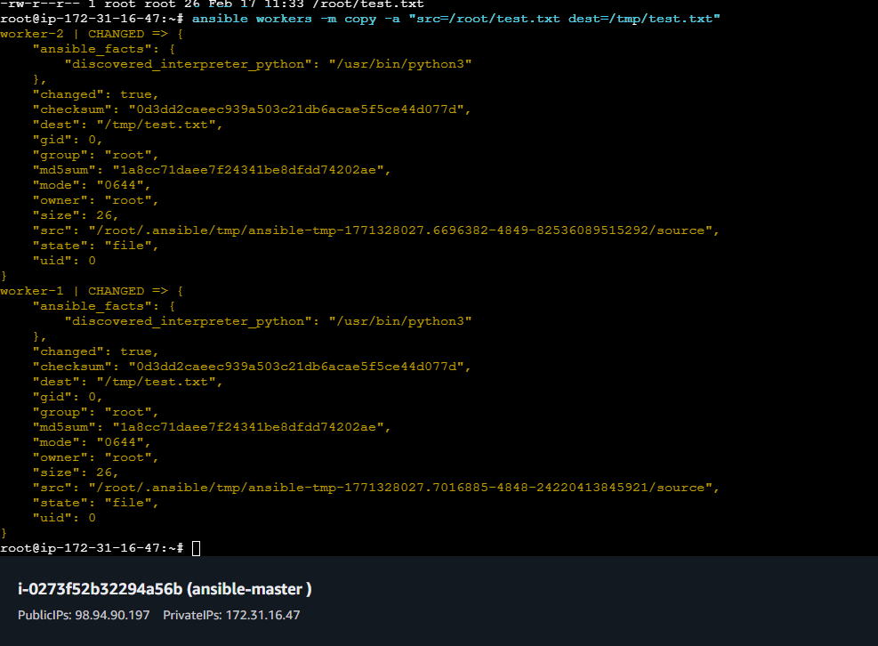
- ansible all -a "df -h"
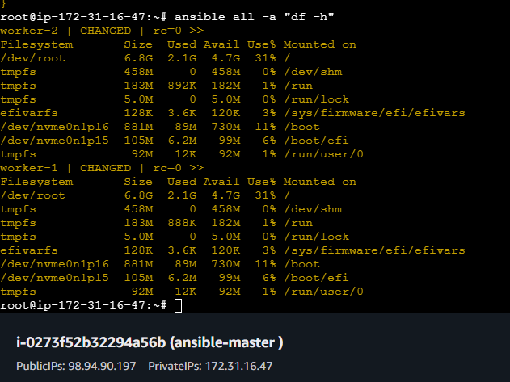

- ansible all -a "free -m"
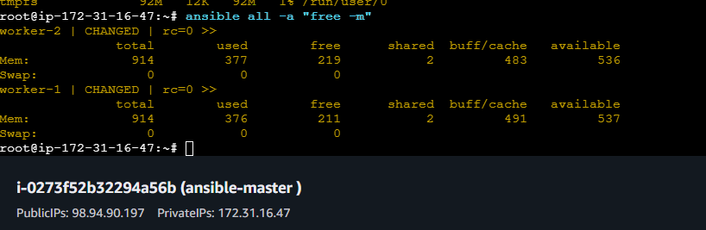
- ansible workers --list-hosts
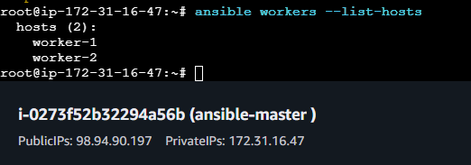
- ansible all -m ping -vvv
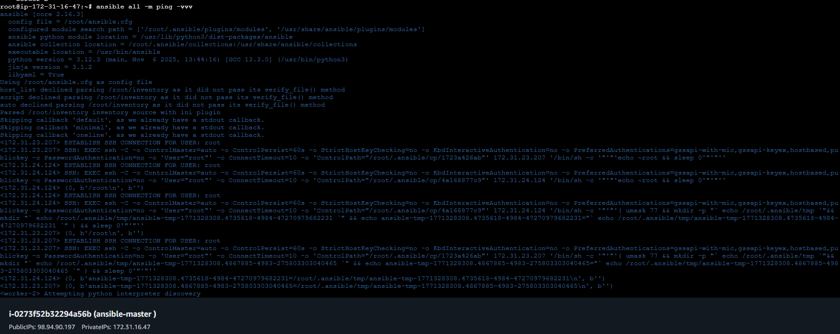
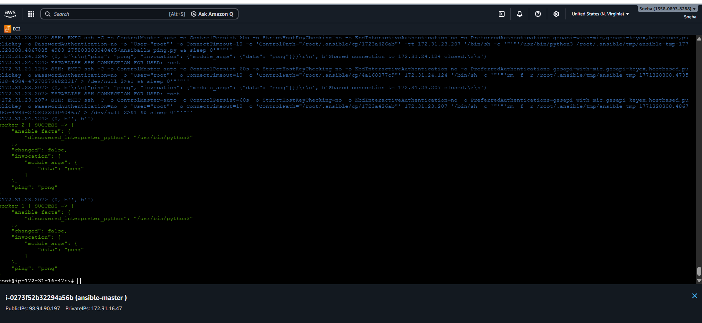
- ansible all -m shell -a "mkdir ansible.log”
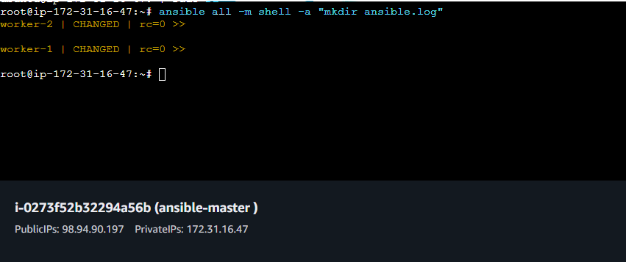
- ls : controller
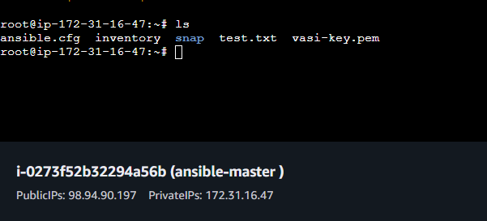

- Worker -01
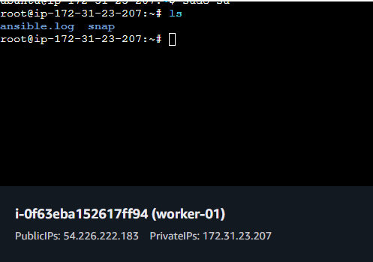
- Worker -02
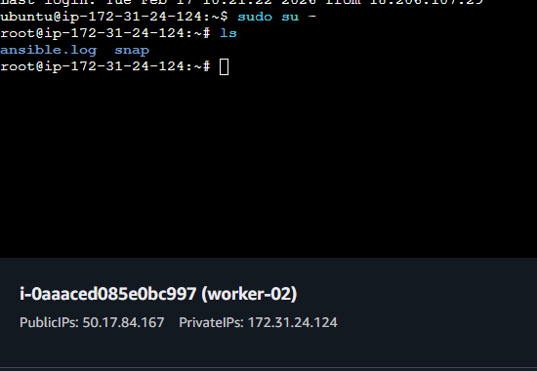
- ansible all -m apt -a "update_cache=yes cache_valid_time=0" -b
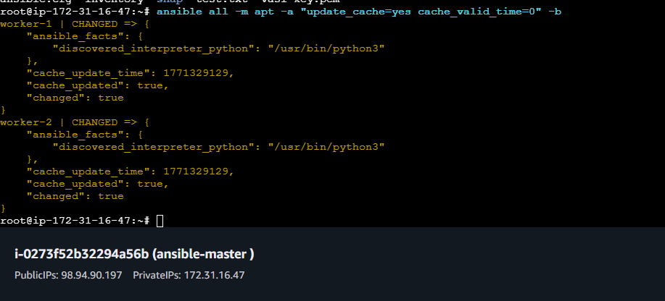
- ansible all -m apt -a "name=apache2 state=present" -b
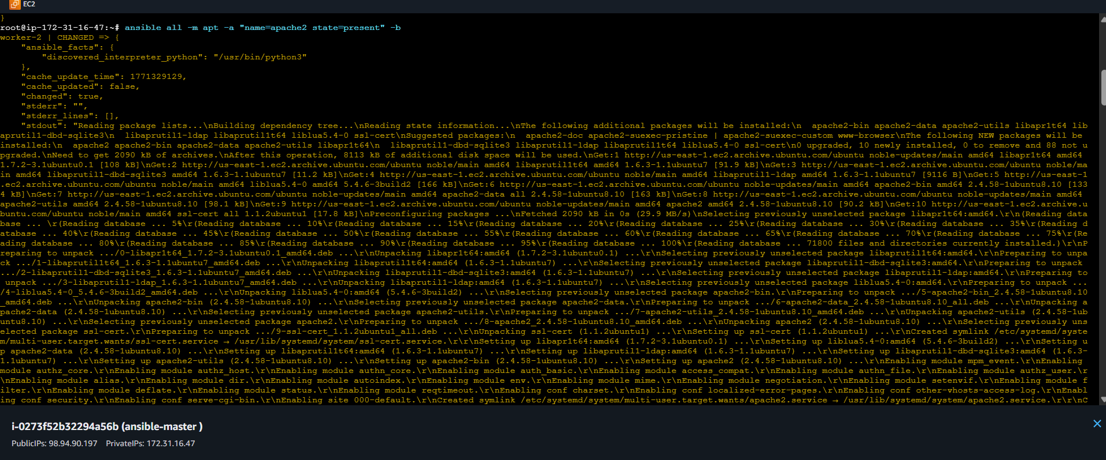
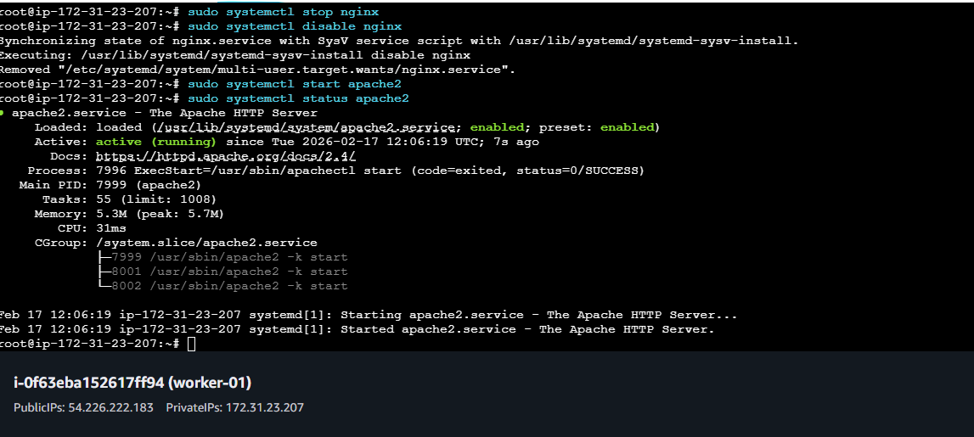
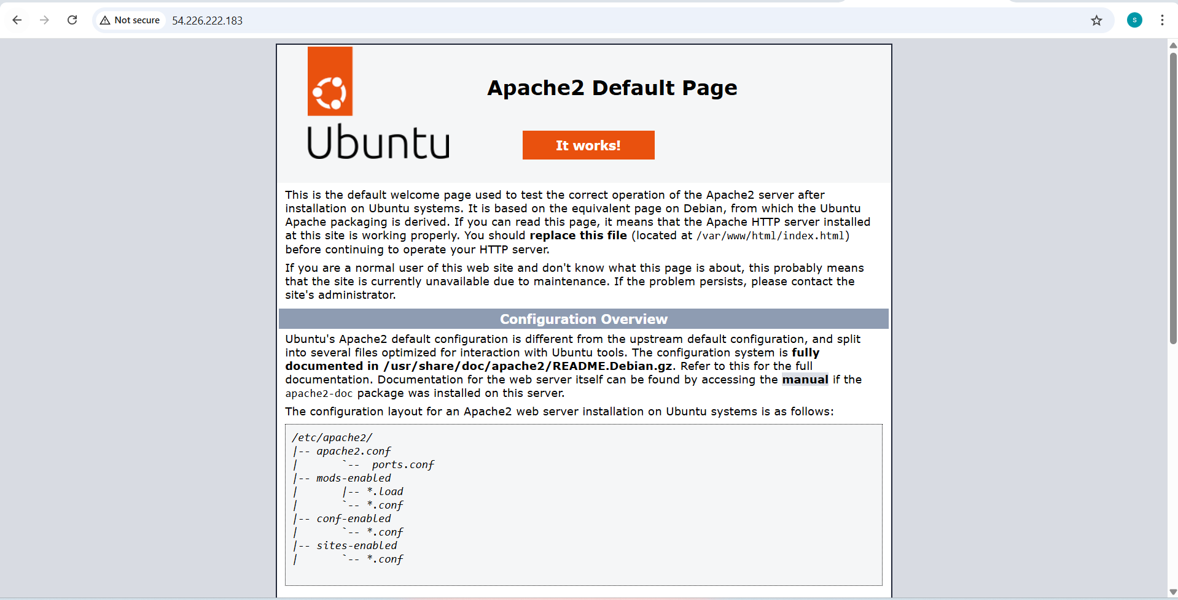
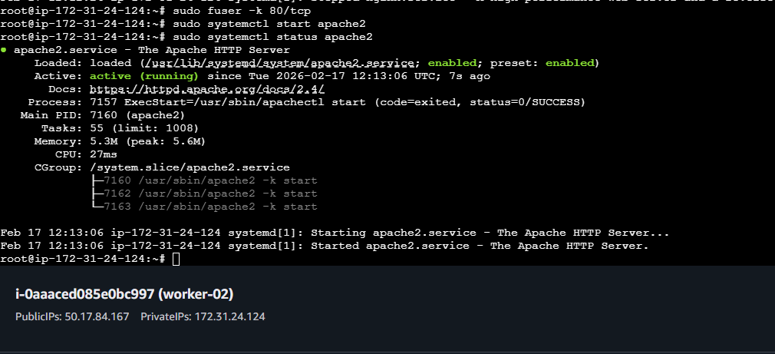
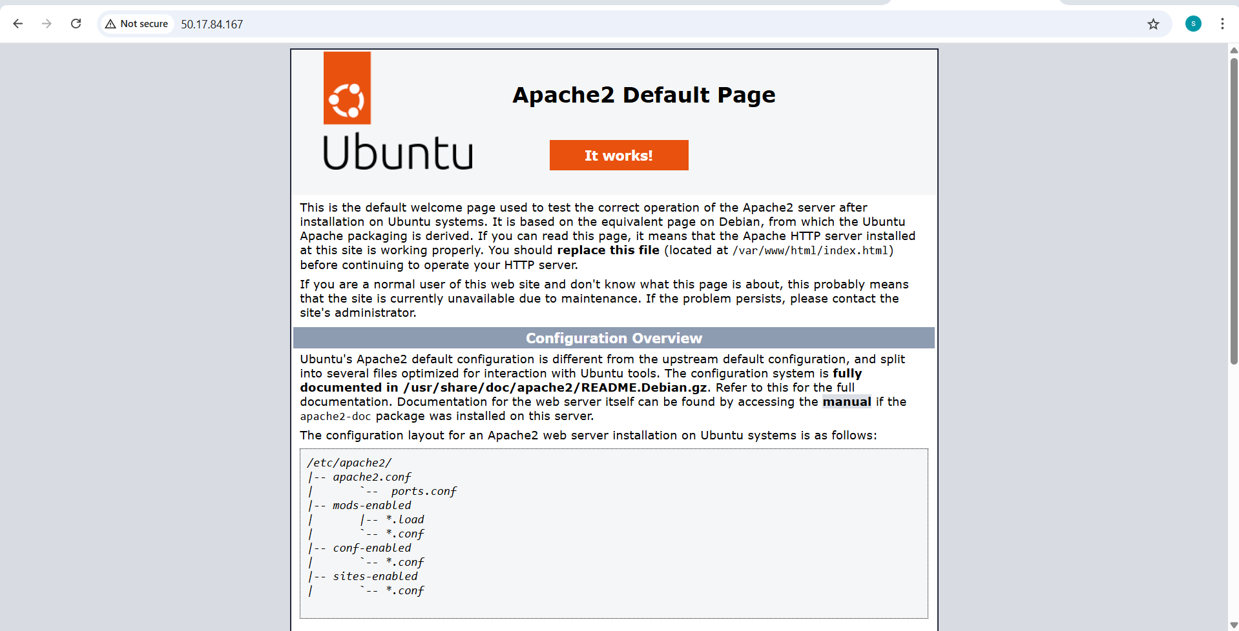
- ansible all -m service -a "name=apache2 state=stopped enabled=yes" -b
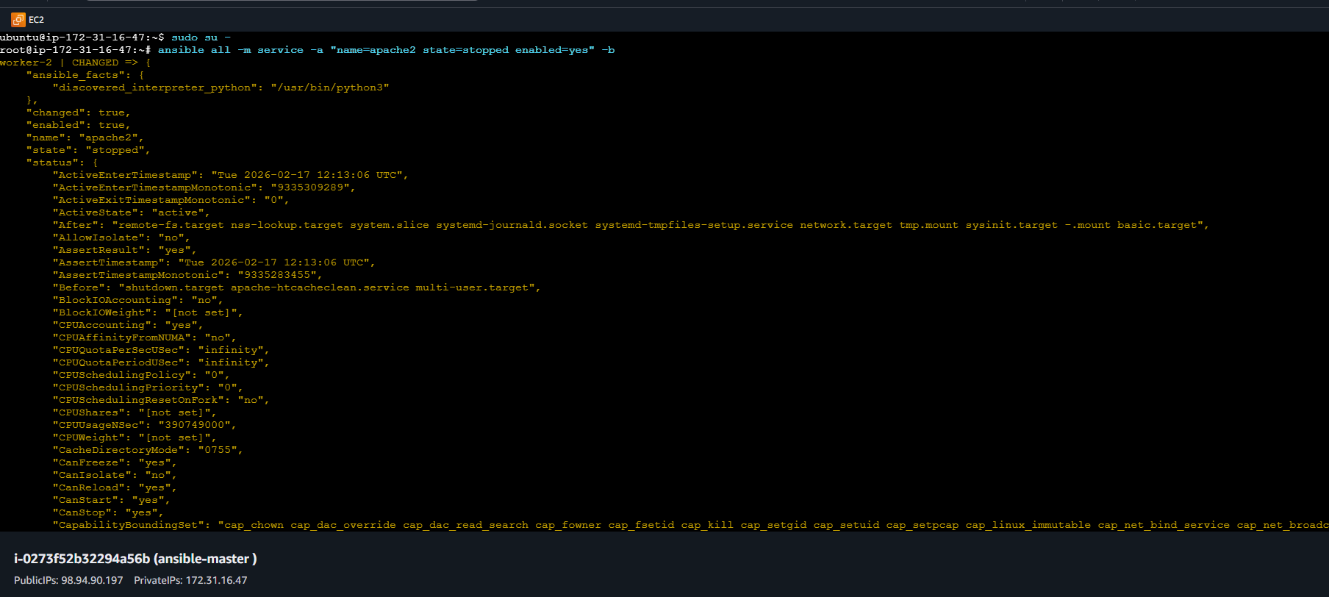
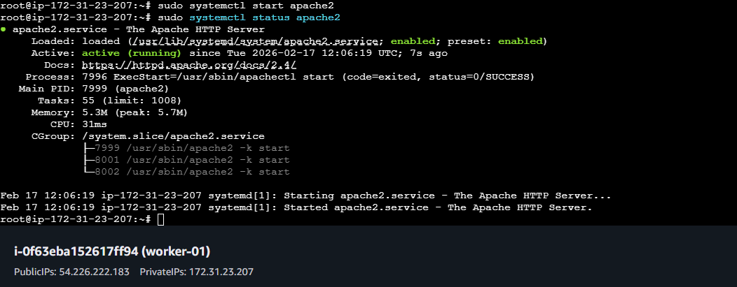
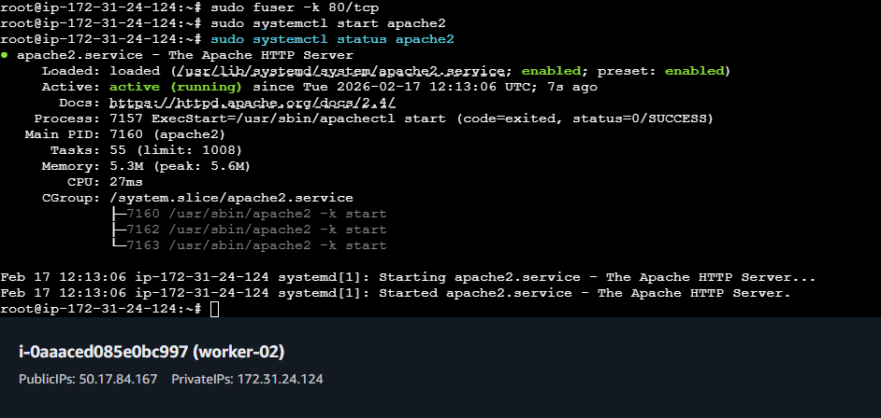
- ansible all -m user -a "name=weblogic state=present"
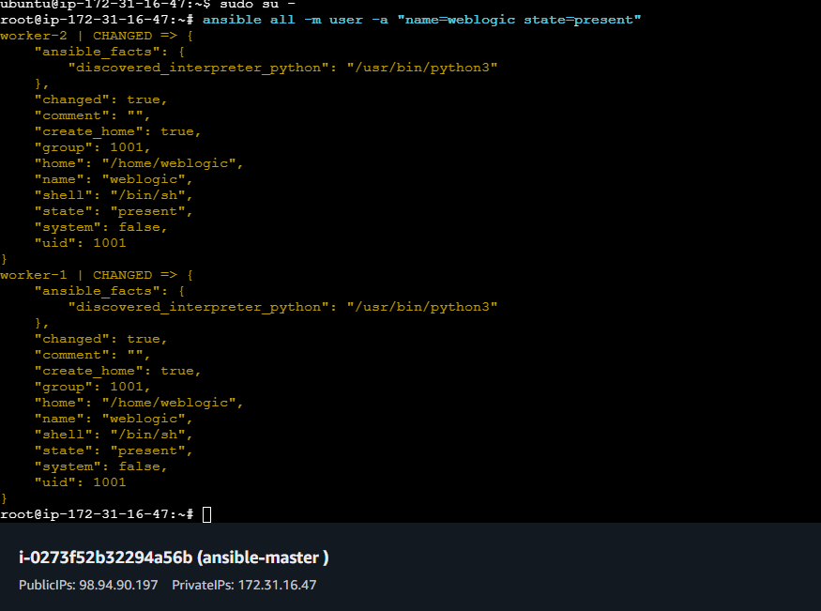
- ansible all -m shell -a "id weblogic"
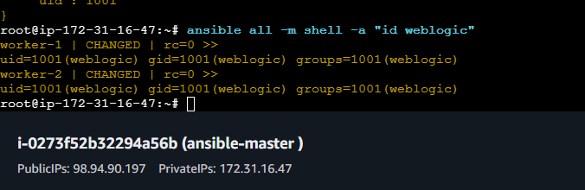
- ansible all -m file -a "path=/root/demo state=touch mode=0755"
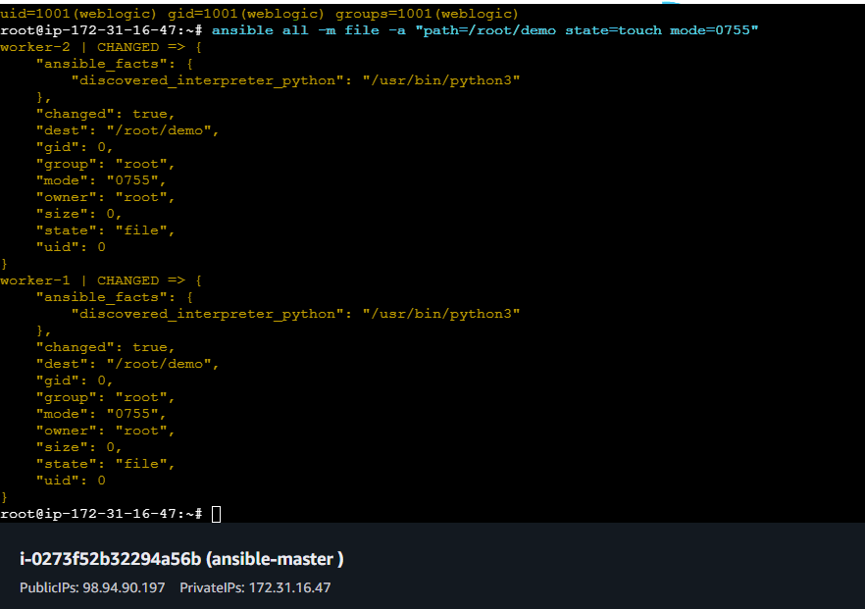
- ansible all -a "ls -l /root/demo" -b
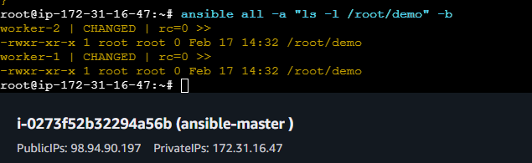
- ansible all -m group -a "name=test state=present" -b -K
